1. Enter the data of the Discharged instrument as seen below. Now you can link the discharged document back to the original instrument.

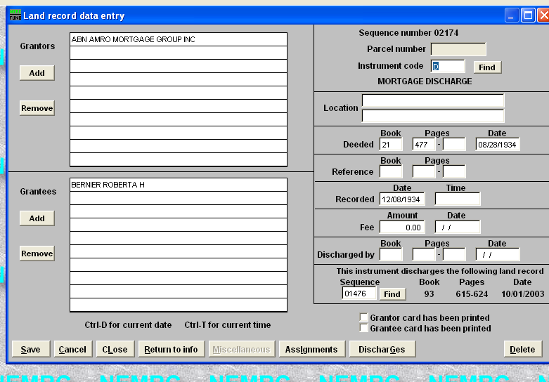

2. Enter the sequence # of the original document that this instrument is to be linked.
If you do not know the sequence # then click the find button to lookup by grantor / grantee.
In this example this instrument is now linked to sequence # 02174.
3. Click the ‘Ok’ button to save your changes when finished. This will link the 2 instruments together meaning you do not have to edit the Mortgage instrument with the Discharge information as it is done automatically.
4. Optional process – If you are editing the original Mortgage you can link the accompanying Discharge using the steps below. This will also link the 2 instruments together automatically as mentioned in step 3.

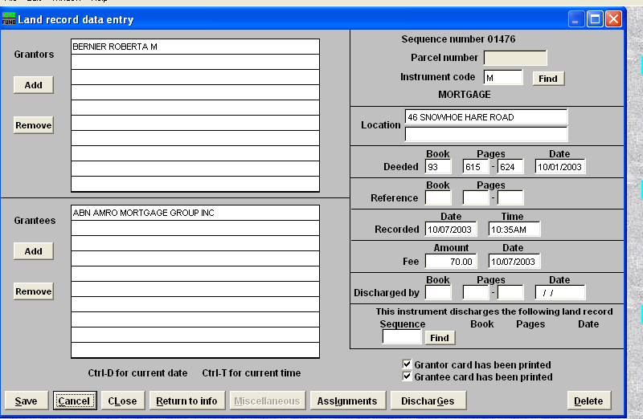

5. Link this instrument to its' discharge instrument by clicking the ‘Discharges’ button.

6. Click on the ‘Add Discharge’ button

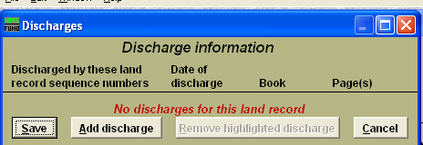

7. Enter the sequence # for the Discharge instrument for this record or click the find button to locate it by grantor or grantee.

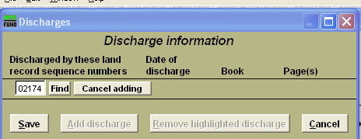

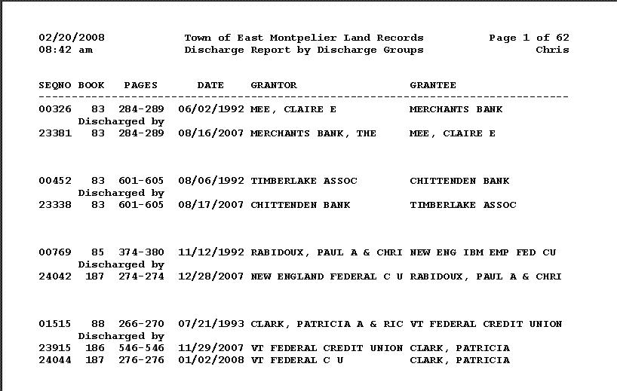
8. Go to the Reports Menu and select ‘G. Discharge Report’ to view a listing of all discharges and the records they are linked with. Below is an example

